Project Report

**News Portal App**

**Introduction:**

The News Portal App project aimed to create a dynamic platform where users can access live news from various sources in real-time. The primary goal was to develop a user-friendly, robust, and scalable web application that delivers up-to-date news content to users efficiently. The project utilized PHP for both frontend and backend development, SQL for database management, and integrated the Bloomberg API to fetch real-time news updates. This report details the project milestones, technological choices, development process, challenges faced, and the outcomes achieved.

**METHODOLOGY:**

Choosing Languages

**Rationale for Choosing PHP:**

Flexibility and Versatility: PHP was selected for both frontend and backend development due to its flexibility and wide range of functionalities. Its ability to embed directly into HTML made it a practical choice for dynamic content generation.

Scalability: PHP is highly scalable, making it suitable for applications that require handling increasing amounts of traffic and data.

Compatibility: PHP's compatibility with various web servers and operating systems ensured that the News Portal App could be deployed on a wide range of environments without compatibility issues.

Community and Resources: The extensive community support and availability of numerous libraries and frameworks facilitated efficient development and troubleshooting.

**Choosing Database**

**Rationale for Choosing SQL:**

Robustness and Reliability: SQL databases are known for their robustness and reliability, making them an ideal choice for handling the critical data of a news portal.

Efficiency in Data Handling: SQL's ability to handle large volumes of data efficiently ensured that the app could manage and retrieve news articles, user information, and other relevant data swiftly.

Structured Data Storage: SQL provided a structured approach to data storage, which was essential for organizing news articles, categorizing them, and ensuring fast and accurate data retrieval.



**Designing the Database Schema**

The database schema was meticulously designed to accommodate various aspects of the news portal:

Tables for News Articles: Included fields such as `article_id`, `title`, `content`, `author`, `publication_date`, `source`, and `category`.

Tables for User Information: Included fields such as `user_id`, `username`, `password`, `email`, and `preferences`.

-Relationships and Indexing: Implemented relationships between tables and indexing on crucial fields to enhance query performance and ensure data integrity.

**Connecting APIs**

Integration of Bloomberg API:

API Selection: The Bloomberg API was chosen for its reputation and reliability in providing real-time financial and general news.

Fetching News: The API was utilized to fetch news articles, headlines, and other relevant information in real-time. This involved sending HTTP requests to the Bloomberg API endpoints and parsing the JSON responses.

Handling API Responses: The data retrieved from the API was processed and stored in the SQL database, ensuring that users received the latest news updates promptly.

Error Handling and Rate Limiting: Implemented error handling mechanisms and rate limiting to manage API requests efficiently and handle any potential API downtimes gracefully.

**Developing the Application**

**Frontend Development:**

User Interface (UI) Design: Focused on creating an intuitive and user-friendly interface. Used HTML, CSS, and JavaScript to design a responsive layout that adapts to various screen sizes and devices.

Interactive Elements: Implemented interactive elements such as search functionality, category filters, and user preferences to enhance the user experience.

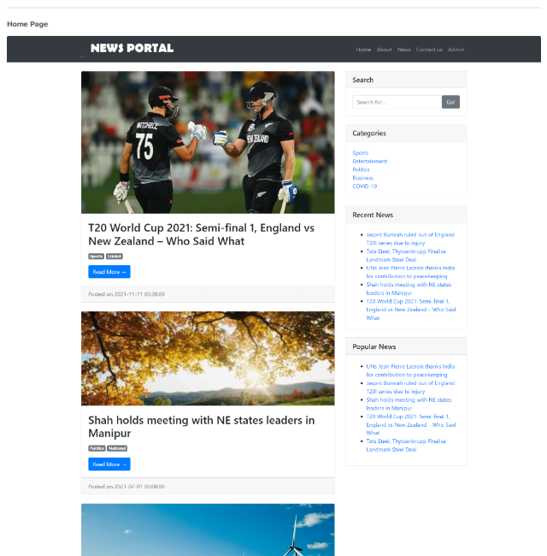

**Backend Development:**

Server-Side Logic: Developed using PHP to handle user requests, interact with the database, and process API data. Ensured that the backend logic was optimized for performance and security.

Authentication and Authorization: Implemented secure user authentication and authorization mechanisms to protect user data and ensure that only authorized users could access certain features.

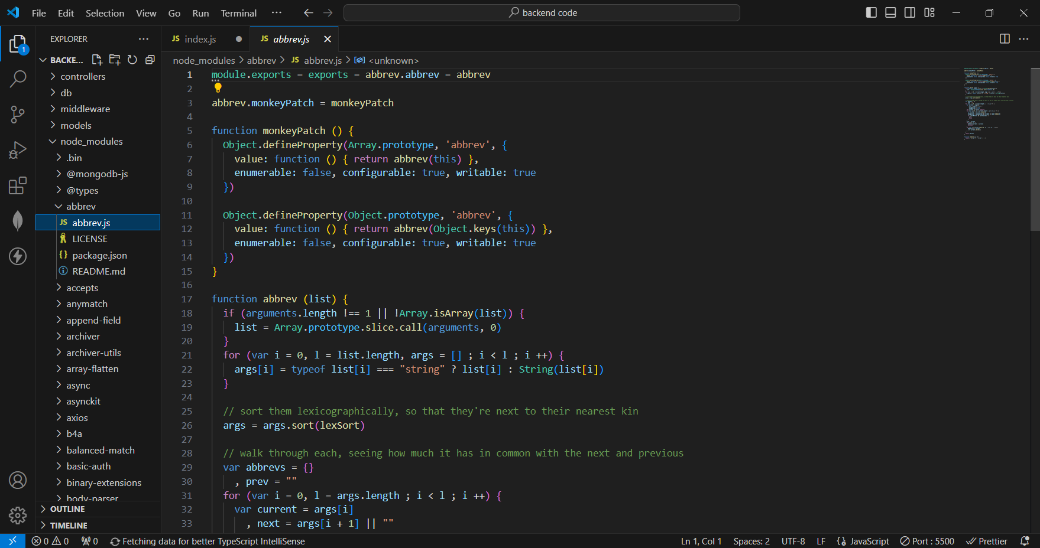

**Deploying the Application**

**Deployment Process:**

Setting Up the Server: Configured a web server environment using Apache or Nginx, ensuring that the necessary PHP and SQL extensions were installed.

Application Configuration: Deployed the PHP application files, configured database connections, and set up environment variables for API keys and other sensitive information.

Testing and Quality Assurance: Conducted thorough testing to identify and resolve any bugs or issues. This included functional testing, performance testing, and security testing to ensure a smooth user experience.

**Post-Deployment Monitoring and Maintenance**

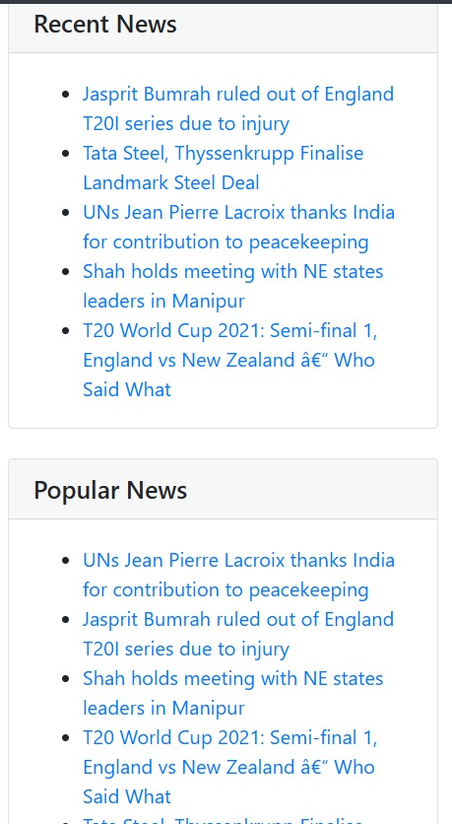

**Monitoring:**

Performance Monitoring: Implemented monitoring tools to track the application's performance, server load, and database queries. Ensured that the application remained responsive under varying traffic conditions.

Error Logging: Set up error logging mechanisms to capture and analyse any runtime errors, facilitating quick identification and resolution of issues.

**Maintenance:**

Regular Updates: Scheduled regular updates to the application and database to incorporate new features, security patches, and improvements based on user feedback.

User Support: Established a support system to address user queries, troubleshoot issues, and gather feedback for continuous improvement.

**Challenges Faced**

**1. API Rate Limiting and Quotas**

***Challenge***: Managing API rate limits and ensuring that the application adhered to Bloomberg's API usage policies.

***Solution***: Implemented caching mechanisms to reduce the number of API requests and used background jobs to fetch and update news data periodically.

**2. Data Consistency and Synchronization**

***Challenge***: Ensuring data consistency between the fetched API data and the SQL database.

***Solution***: Developed a synchronization script that periodically compared and updated the database with the latest API data, handling any discrepancies gracefully.

**3. User Authentication and Security**

***Challenge***: Implementing secure authentication and protecting user data from potential threats.

***Solution***: Used industry-standard security practices, including hashing passwords with bcrypt, implementing HTTPS, and conducting regular security audits.

**Project Outcome**

The News Portal App project was successfully developed and deployed, achieving all key milestones and objectives. Users can access live news updates through the app, powered by Bloomberg API integration. The platform provides a seamless experience for users to stay informed about current events, breaking news, and trending topics.

**User Feedback and Reception**

Positive Reception: Users have praised the app for its user-friendly interface, real-time updates, and reliability.

High Engagement: The app has seen high user engagement, with users frequently returning to check for the latest news.

**Conclusion:**

The News Portal App project has been a success, providing users with a valuable platform to access live news content. The use of PHP for frontend and backend development, SQL for the database, and Bloomberg API integration has enhanced the app's functionality and performance. The deployment of the app has made it accessible to a wide audience, contributing to its success as a reliable source of news updates. The project report demonstrates the project's progress, achievements, and final outcome, showcasing the team's dedication and expertise in creating a news portal app.

**Future Enhancements**

1. Expanding News Sources

Integration with Additional APIs: Plan to integrate additional news APIs to provide a wider range of news sources and categories.

2. Personalization and Recommendations

User Preferences: Implementing features to personalize news feeds based on user preferences and reading habits.

Recommendation Engine: Developing a recommendation engine to suggest news articles based on user behaviour and interests.

3. Mobile Application

Mobile App Development: Creating a mobile application version of the News Portal App to enhance accessibility and user engagement on mobile devices.

4. User Interaction Features

Comments and Discussions: Adding features for users to comment on and discuss news articles, fostering a sense of community and engagement.

By continually enhancing and expanding the News Portal App, the project aims to provide an even richer and more engaging experience for users, solidifying its position as a leading platform for accessing live news updates.